**ANNUAL GENERAL REPORT 2020**

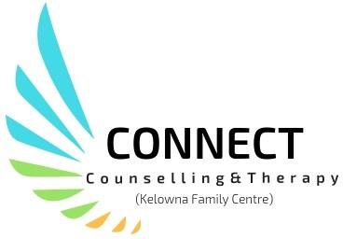

**Counselling for the Community**

## Connect Counselling & Therapy: Central Okanagan

#### Tel: 250-860-3181204-347 Leon Avenue Email: [connectcounselling@shaw.ca](mailto:connectcounselling@shaw.ca) Fax: 250-860-3188 [www.connectcounsellingsociety.ca](http://www.connectcounsellingsociety.ca/)

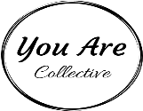

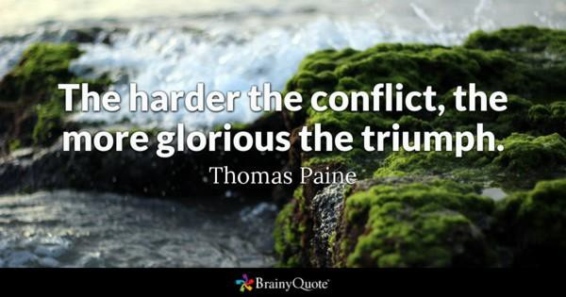

Message from the Executive Director

As we look back on the year, who could have predicted COVID-19 and its impact on us socially, emotionally and economically. The disease has encroached not only on public health but on global economic well-being and on some of the most fundamental practices of modern society. It has generated great anxiety and exacted an enormous and growing human toll. And it has required virtually every organization to reinvent its processes to cope with a world in which many people simply don’t feel safe being in the same room together.

Never before has the call to action been louder to reach out to those individuals living with long-term mental health problems, and to victims of intimate partner violence!

As an organization Connect rose to the challenge! We embraced technology, navigated tele-health platforms, and found new ways of reaching our clients. We continued with individual counselling and groups. We came together as a team despite working remotely.

Worthy Moments:

Somatic Experiencing Training Beginner One was offered with 51 participants in attendance. Facility member Dea Parsanishi from the Somatic Experiencing Trauma Institute gave an informative 3 day training. Plans are under way for Beginner Two which will be held in October.

Purppl was hired to provide direction as Connect expands access services to the community via our Fee for Service Program.

Kelowna Women’s Shelter and Connect partnered to offer the first trauma group for men called “The Discovery of the Roots of Self”. This 24 week group provided in-depth trauma counselling to men impacted by childhood abuse.

You Are Collective a grassroots clothing company is working towards providing one million counselling sessions to our community. Connect is a proud partner and recipient of funding, which has been ear-marked to provide specialized trauma counselling.

Connect Counselling, UBCO & E-Fry began a collaborative project to develop workplace curriculum to help employers support workers who disclose Domestic Violence.

To my Team-thank you for your outstanding dedication to our clients! To our community supporters and partners your belief in our work makes it possible to effect positive change in our community!



Roxie Van Aller, Executive Director

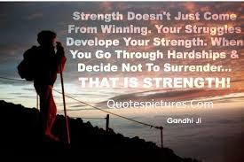

Message from the Board of Directors

It's hard to believe that a year ago we held our AGM at the curling club. There were snacks and conversations and normalcy - and then 2020 happened. This year has been a challenge for everyone. Mental health support is more important now than ever, and the services we provide impact not just our clients, but their families, workplaces, and our community as a whole.

This could easily have been a year of defeat. We could have sat back and waited for the pandemic to be over and our world to return to normal. But instead, we have come together to make this a year of triumph! The board is so impressed at the level of commitment shown by the staff. Your capacity for creativity, flexibility, and problem solving, even when faced with the effects of the pandemic in your own lives, is incredible. Thank you for meeting the challenge of virtual counseling and helping Connect grow.

And thank you, Roxie. The board is constantly in awe of your ability to juggle your mountain of day to day responsibilities while still maintaining passion and creativity. Your ability to see, not just today’s ‘to- do’ list, but where Connect COULD be in the future is such an asset. Thank you for your tireless hard work and for your excellent leadership.

In August, with the assistance of Purppl, we came together and completed a very successful strategic planning session - over Zoom no less! Over the next few months, the board will start working on our identified priorities to ensure our foundation is strong as we move forward. If any of you are interested in being more involved with the implementation of the strategic plan, please let us know

I am proud to be a part of this organization and excited to see where the next AGM will find us.

Sincerely,



Caitlyn Harris - Board Chair

# WHAT WE DO

To fulfill its mission to respond to community needs by fostering well-being and healthy relationships through skilled counselling services, Connect Counselling & Therapy currently focuses on 6 broad service areas, which include:

* Individual counselling for Women, Children/Youth & Men
* Groups for Women, Children & Men
* Couples Counselling
* Trauma Counselling
* Fee for Service
* Parenting Education

The ultimate aim of Connect Counselling & Therapy is to positively affect the lives of our community members by, promoting healthy relationships by supporting individuals, families and seniors.

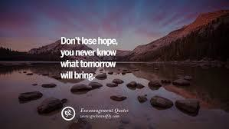

**Counselling for Women, Children/Youth & Men**

***Women’s Counselling****,*

Individual and group counselling to women over the age of nineteen who have experienced childhood abuse, abuse in adult relationships and/or sexualized violence.

Short term counselling for balancing the demands of family, struggles with life transitions or losses, relationship conflicts.

***Children & Youth Counselling***

Services for children, youth and their families who may be experiencing challenges with difficult behavior, separated or blended families, parent/child conflicts, parenting, grief, loss and sexual intrusive behavior.

###### Men’s Counselling

Provides individual (short term) and/or group counselling based on the needs of men who would like to improve their relationships, reduce stress and manage conflict.

***“There is no way I would have gotten through quarantine without the ability to connect with Connect Counselling through virtual meeting spaces. By continuing to meet it helped ground me, know that I wasn’t alone, and prevented me from putting a pause (or most likely a reverse) on my post trauma healing work. Thank you.” Discovering the Roots of Self participant***

***Couples Counselling***

Provides a safe place where couples can explore relationship difficulties and work to resolve interpersonal conflict, improve communication and increase intimacy.

***Fee for Service***

Fee for service is available for individuals who wish to pursue counselling issues not already covered by regularly funded programs.



***“Our couple’s counsellor provided us with techniques which has helped my relationship!”***

***Couples Counselling Program***

**Groups for Women, Children, Men and Families**

***SOOTHE for Children***

* A course to support children aged 6-12 to reduce anxiety. A parenting component included.

***Children & Change Group***

* A group for children aged 6-12 whose parents have separated or divorced.

***Parenting Skills Class***

* Supports parents in developing skills to address challenging behaviours in their children or teens.

***Reaching Older Women (ROW) Group***

* For women 50+ who have experienced historical or current intimate partner violence.

***Rebuilding For Adults***

* A psycho-educational group for adults to who would like information and support after their relationship ends.

***Lowering Anxiety through Self-Regulation for Adults***

* A skill building course to help adults to reduce their anxiety.

**Ongoing Drop-in Groups**

***Finding Our Voices Drop-in Group***

* A group for women impacted by childhood and/or relationship abuse.

***Men in Change***

* A process group for men who are interested in learning how to manage emotions and conflict. Themes include: unfairness, boundary work, respectful communication, family conflict, solution-focused work, managing anger, emotional intelligence, shame

and resiliency.

***Men in Relationship with Self and Others***

* A group for men striving to improve their communication or relationship skills, conflict resolution skills, and who may be struggling with separation or divorce.

***“The informational side of things was great but what really blew me away was the connection, safety and vulnerability that we all developed in that room”. Men’s group participant***

**Parenting Education**

***Parenting Skills Class***

* Supports parents in developing skills to address challenging behaviours in children or teens.

***Thriving and Surviving Blended Families***

* Discover how to make your marriage work in sometimes tough terrain. Learn to navigate the challenges of blending two existing families into one cohesive whole. Explore how different parenting styles, finances, relationships with ex-spouses and legal matters can chisel away at your union if you don’t make your marriage a priority.



***“I think people should go to this class in order to improve the important skills for both***

***parents and children”. “Having an opportunity to talk and hear other parent’s struggles helped me to feel normal”.***

**WHY IT MATTERS**

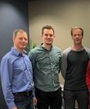

Facilitators Darcy Kuhl, Michael Patzer, Jeff Goreski

*“I was an attendee from the Thursday night men’s trauma group since it started in September. I just wanted to say that what I experienced during that time was life changing in so many ways. First off, Jeff and Darcy did an awesome job facilitating the group! They were welcoming, passionate and informative amongst many other attributes. The informational side of things was great but what really blew me away was the connection, safety and vulnerability that we all developed in that room.*

*I actually grieved when I realized that the group was coming to an end as that was the most safety and honesty I've felt in my whole adult life. Even though Darcy and Jeff were the facilitators of the group we all got a lot from the group in so many ways, it gives me goosebumps to think about it.*

*I've made many strides since that group, improved my relationships and made many friends as well. So for that I'm very thankful as I’m feeling myself again for the first time in a long time!*

*Thanks to Connect Counselling!”*

**COMMUNITY NEED**

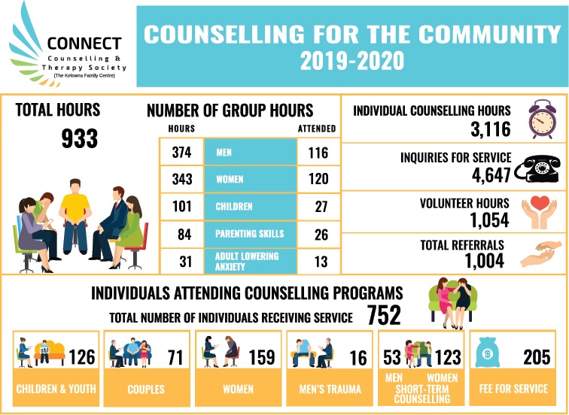

**Connect Counselling & Therapy**

|  |  |  |
| --- | --- | --- |
| **Usage** | **Year: 2019-20** | **Year: 2018-19** |
| Inquiries for service | 4,647 | 4103 |
| Referrals | 1,004 | 1055 |
| Counselling hours | 3,116 | 3053 |
| Group hours | 933 | 661 |
| Fee for Service | 205 | 160 |
| Volunteer Hours | 1,054 | 742 |
| **Total Clients Served** | **752** | **742** |

**FINANCIAL STATEMENT**

##### Connect Counselling and Therapy Society (Kelowna Family Centre)

###### Statement of Financial Position March 31, 2020

***(Unaudited)***

**2020** 2019

##### Assets

CURRENT

Cash **$** 109,801 $ 76,008

Accounts receivable **7,290** 4,229

Prepaid expenses **-** 5,482

GST recoverable **2,989** 1,716

|  |  |  |
| --- | --- | --- |
|  | 120,080 | 87,435 |
| Property, Plant & Equipment (note 5) | **6,242** | 6,958 |
| RESTRICTED CASH (Note 4) **24,745** 24,341 | | |
| **LIABILITIES AND NET ASSETS** | **$ 151,067** | $ 118,734 |
| CURRENT  Accounts payable | **$ 7,707** | $ 4,922 |
| Goods & services tax payable | **1,703** | - |
| Wages payable | **22,269** | 14,129 |

Deferred revenue (Note 7) **51,553** 47,492

**83,232** 66,543

##### NET ASSETS

|  |  |  |
| --- | --- | --- |
| Net assets invested in capital assets | **$ 6,242** | $ 6,958 |
| Restricted net assets (note 4) | **24,745** | 24,341 |

Unrestricted net assets

**36,848** 20,892

**52,191** 52,191

**$ 151,067** $ 118,734

**STATEMENT OF REVENUES & EXPENDITURES**

#### Connect Counselling & Therapy Society (Kelowna Family Centre)

###### Year Ended March 31, 2020 (Unaudited)

**2020** 2019

|  |  |  |
| --- | --- | --- |
| **REVENUES**  Counselling | **$ 57,267** | $ 65,315 |
| Donations and Fundraising | **8,007** | 19,806 |
| Grant - Community Gaming *(Note 3)* | **23,775** | 16,902 |
| Grants - Other | **61,168** | 33,478 |
| Grants - Provincial Government | **394,472** | 392,380 |
| Somatic Experience course fundraiser *(Note 7)* | **50,970** | - |
| Interest | **732** | 343 |
|  | **596,391** | 528,224 |
| COST OF SALES |  |  |
| Contract services | **43,708** | 20,415 |
| Program supplies | **5,343** | 4,129 |
| Salaries and benefits | **379,969** | 375,386 |
| Travel | **4,042** | 3,174 |
|  | **433,062** | 403,104 |
| GROSS PROFIT | **163,329** | 125,120 |
| **EXPENSES**  Advertising | **6,885** | 6,823 |
| Amortization | **1,840** | 2,074 |
| Communication | **4,514** | 4,347 |
| Fundraiser expenses | **184** | 3,012 |
| General and board meetings | **1,390** | 1,293 |
| Insurance | **4,214** | 4,084 |
| Office and general | **14,292** | 11,352 |
| Professional development | **4,603** | 2,749 |
| Professional fees | **4,745** | 4,499 |
| Rent | **35,876** | 35,916 |
| Repairs and maintenance | **4,504** | 3,728 |
| Salaries and wages | **24,079** | 23,032 |
| Somatic Experience course expenses *(Note 7)* | **40,040** | - |
| Security | **519** | 507 |
|  | **147,685** | 103,416 |
| **EXCESS OF REVENUES OVER EXPENSES** | **$ 15,644** | $ 21,704 |

# HOW YOU HELP

### VOLUNTEERS

Our volunteers help in many ways, from becoming a board member, administrative support, fund development and fundraising.

**DONATIONS**

We rely on the generosity of the community and grants in order to provide the programming and do what we do. The support we recieive from fund rasing events, donations and third party events makes all the difference!

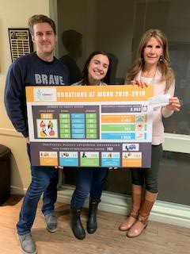

**YOU ARE COLLECTIVE FIRST TRAUMA COUNSELLING DONATION!**

You Are Collective is a mental health social enterprise to empower and share lived experience to end the stigma surrounding Mental Health struggles.

# WHO WE ARE

#### ADMINISTRATIVE TEAM

Executive Director: Roxie Van Aller Office Manager: Joanna Shaw Administrative Support: Bonnie Williams Finance Coordinator: Lynda Fillion Gabrielle Smith-Lee (Volunteer)

**COUNSELLING STAFF**

Suzanne Harrington Joyce Eng

Michelle DeVies John Downes Kim Wardman

Angela Kazmierczak Roxie Van Aller

**COUNSELLING CONTRACTORS**

JB Cole Liz Sage

Lois Hansen Jeff Goreski Lisa Binnie Darcy Kuhl

**BOARD**

Board Chair: Caitlyn Harris Co-Chair: Michelle Sinotte Secretary: Richard Swanson Treasurer: Cinda Carlston Terry Smith

Stephen Somerville Mark Smed

Ann Haymond-Hill Nancy Guy