**ANNUAL GENERAL REPORT 2021**

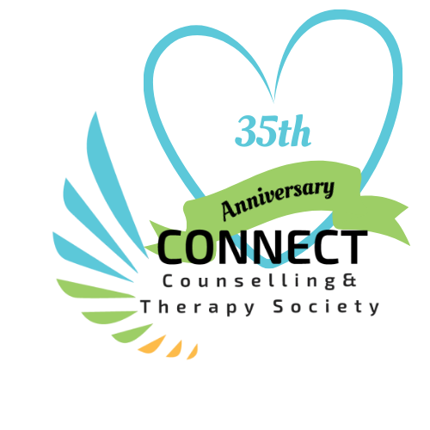

**Counselling for the Community**

## Connect Counselling & Therapy: Central Okanagan

#### Tel: 250-860-3181204-347 Leon Avenue Email: [connectcounselling@shaw.ca](mailto:connectcounselling@shaw.ca) Fax: 250-860-3188 [www.connectcounsellingsociety.ca](http://www.connectcounsellingsociety.ca/)

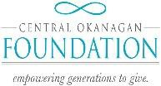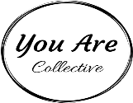



**Message from the Executive Director and Board**

This year Connect celebrates 35years of providing counselling services in the Central Okanagan! Spearheaded by the late Frank McNair Connect was incorporated in 1886 and awarded its first contract with the Ministry of Health in 1987. It has undergone many changes over the years. The number of programs has grown from the original Child and youth Counselling contract to include adult counselling, groups for men, women and children, alongside parenting groups, men’s groups, groups for families and seniors in transition, and services for women in intimate partner violence. From its humble beginning our focus has always been on providing counselling and education, that makes a difference in the lives of individuals and families in the community. Some 35 years later we carry on with this vision together with our community partners. Today Connect has broad-based funding from a variety of provincial governments and support from local foundations.

This past year Connect provided 3114 free counselling sessions to 541 individuals with an approximate value of $404,820!

**Highlights:**

As an organization Connect continues to rise to the challenge! We have become masters of technology, navigating tele-health platforms to offer groups as well as individual appointments. We have continued to reach our clients; and to remain connected as a team in spite of working remotely.

We continued to build our social enterprise offering our highly skilled services to individuals through ICBC, First Nations health authority and Autism BC. With the goal of providing more free counselling services to the community.

With support from Emergency Funding through the Central Okanagan Foundation we provided an online group for youth who were experiencing anxiety due to COVID-19. This funding supported 16 youth struggling to cope with the challenges of online learning and separation from peers and family.

Emergency Funding through The United Way provided support to women who were at increased risk of intimate partner violence, by providing funds for a Domestic Violence Advocate and Navigator. Over 50 women received support.

Somatic Experiencing Training went online! Level Beginner two & Three were completed with 51 participants in attendance. Facility member Dea Parsanishi from the Somatic Experiencing Institute continued to inspire and challenge students attending the online training.

Connect Counselling in collaboration with UBCO offered an eight-week group Healthy Relationship group for students. Feedback from participants was very positive. A plan is in place to offer the group again in the fall.

To my Team-thank you for your outstanding dedication to our clients You continue to amaze me! To our community supporters and partners your belief in our work makes it possible to effect positive change in our community!



Roxie Van Aller, Executive Director

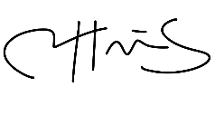

Caitlyn Harris Board Chair

# WHAT WE DO

**Mission:** To offer affordable, high quality, non-crisis care to improve the mental health of our diverse clients, their families and their communities.

Connect Counselling & Therapy currently focuses on 6 broad service areas, which include:

* Individual counselling for Women, Children/Youth & Men
* Groups for Women, Children & Men
* Couples Counselling
* Trauma Counselling
* Fee for Service
* Parenting Education

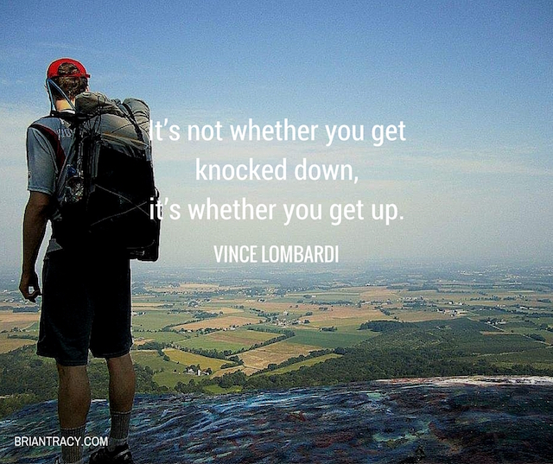

**Impact:**

Improved overall mental health and well-being of all residents of the Central Okanagan who seek support, leading to measurably stronger, healthier communities.

**Counselling for Women, Children/Youth & Men**

***Women’s Counselling****,*

Individual and group counselling to women over the age of nineteen who have experienced childhood abuse, abuse in adult relationships and/or sexualized violence.

**Short term Counselling** for balancing the demands of family, struggles with life transitions or losses, relationship conflicts.

***Children & Youth Counselling***

Services for children, youth and their families who may be experiencing challenges with difficult behavior, separated or blended families, parent/child conflicts, parenting, grief, loss and sexual intrusive behavior.

###### Men’s Counselling

Provides individual (short term) and/or group counselling based on the needs of men who would like to improve their relationships, reduce stress and manage conflict.

***“I am writing because I wish to express a deep appreciation of the Connect Counselling services in all my experiences with them. From the first time I called, I received a very gentle, human, and relaxed interaction with staff; who were welcoming, inclusive and easy-going as well as kindly towards wherever I was coming from and for whatever needs I had.*** ***The counsellors themselves are each very individual, but offer a cohesive, clear and gentle offerings to me.***

***Couples Counselling***

Provides a safe place where couples can explore relationship difficulties and work to resolve interpersonal conflict, improve communication and increase intimacy.

***Fee for Service***

Fee for service is available for individuals who wish to pursue counselling issues not already covered by regularly funded programs.



**Groups for Women, Children, Men and Families**

***SOOTHE for Children***

* A course to support children aged 6-12 to reduce anxiety. A parenting component included.

***Children & Change Group***

* A group for children aged 6-12 whose parents have separated or divorced.

***Parenting Skills Class***

* Supports parents in developing skills to address challenging behaviours in their children or teens.

***Reaching Older Women (ROW) Group***

* For women 50+ who have experienced historical or current intimate partner violence.

***Rebuilding For Adults***

* A psycho-educational group for adults to who would like information and support after their relationship ends.

***Lowering Anxiety through Self-Regulation for Adults***

* A skill building course to help adults to reduce their anxiety.

**Ongoing Drop-in Groups**

***Finding Our Voices Drop-in Group***

* A group for women impacted by childhood and/or relationship abuse.

***Men in Change***

* A process group for men who are interested in learning how to manage emotions and conflict. Themes include: unfairness, boundary work, respectful communication, family conflict, solution-focused work, managing anger, emotional intelligence, shame

and resiliency.

***Men in Relationship with Self and Others***

* A group for men striving to improve their communication or relationship skills, conflict resolution skills, and who may be struggling with separation or divorce.

***“I have been participating in the Wednesday night ‘Men in Relationships’ discussion group, and look forward to it, as a safe place to talk about what’s on my mind. It provides a space where men can discuss what they are feeling with honesty and realness, without feeling like they are being judged. In this way, it promotes a healthy masculinity, something this world needs.***

***For me, my mental health is key to my overall health, and being able to speak openly in a non-judgmental environment is a necessary first step”.***

**Parenting Education**

***Parenting Skills Class***

* Supports parents in developing skills to address challenging behaviours in children or teens.

***Thriving and Surviving Blended Families***

* Discover how to make your marriage work in sometimes tough terrain. Learn to navigate the challenges of blending two existing families into one cohesive whole. Explore how different parenting styles, finances, relationships with ex-spouses and legal matters can chisel away at your union if you don’t make your marriage a priority.



***“The content in the Parenting Skills Group was excellent”. Really helped to put some parenting challenges into perspective!”***

**WHY IT MATTERS**

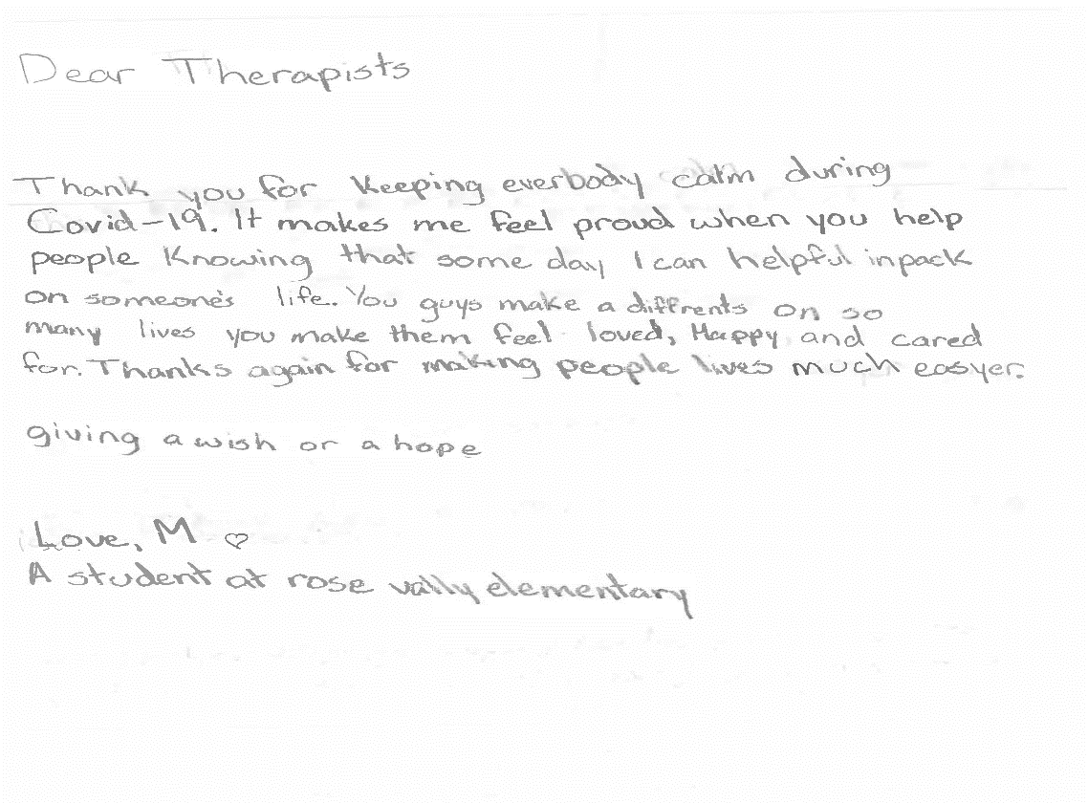

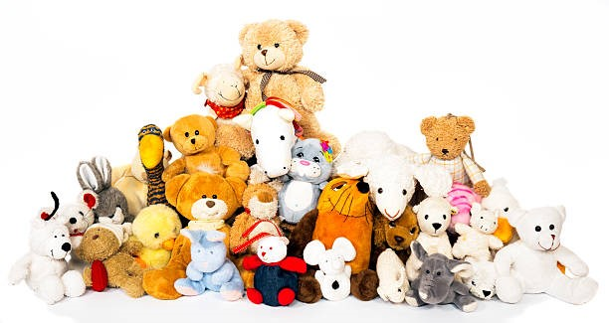

**COMMUNITY NEED**

**Connect Counselling & Therapy**

|  |  |  |
| --- | --- | --- |
| **Usage** | **Year: 2020-21** | **Year: 2019-20** |
| Inquiries for service | 1190 | 1098 |
| Referrals | 778 | 1004 |
| Counselling hours | 3,114 | 3116 |
| Group hours | 485 | 933 |
| Fee for Service | 175 | 205 |
| Volunteer Hours | 730 | 1054 |
| **Total Clients Served** | **541** | **752** |

**FINANCIAL STATEMENT**

##### Connect Counselling and Therapy Society (Kelowna Family Centre)

###### Statement of Financial Position March 31, 2021

***(Unaudited)***

**2021** 2020

##### Assets

CURRENT

Cash **$ 193,966** $ 109,801

Accounts receivable **7,752** 7,290

Prepaid expenses **3,067** 2,989

**$ 204,785** $ 120,080

|  |  |  |
| --- | --- | --- |
|  |  |  |
| Property, Plant & Equipment (note 5) | **7,542** | 6,242 |
| RESTRICTED CASH (Note 4)  **25,043** 24,745 | | |
| **LIABILITIES AND NET ASSETS** | **$ 237,370** | $ 151,067 |
| CURRENT  Accounts payable | **$ 15,843** | $ 7,707 |
| Goods & services tax payable | **1,187** | 1,703 |
| Wages payable | **34,531** | 22,269 |

Deferred revenue (Note 6) **51,553** 22,269

**110,788** 83,232

##### NET ASSETS

|  |  |  |
| --- | --- | --- |
| Unrestricted net assets | **$ 93,997** | $ 36,848 |
| Restricted net assets (note 4) | **25,043** | 24,745 |
| Net assets invested in capital (note 5) | **7,542** | 6,242 |
|  | **126,582** | 67,835 |
|  | $237,370 | $151,067 |
|  |  |  |
|  |  |  |
|  |  |  |
|  |  |  |
|  |  |  |
|  |  |  |
|  |  |  |

**STATEMENT OF REVENUES & EXPENDITURES**

#### Connect Counselling & Therapy Society (Kelowna Family Centre)

###### Year Ended March 31, 2021 (Unaudited)

**2021** 2020

|  |  |  |  |
| --- | --- | --- | --- |
| **REVENUES**  Counselling | **$ 49,866** | $ 57,267 | |
| Donations and Fundraising | **15,147** | 8,007 | |
| Grant - Community Gaming *(Note 3)* | **28,524** | 23,775 | |
| Grants - Other | **125,093** | 61,168 | |
| Grants - Provincial Government | **428,5852** | 394,472 | |
| Somatic Experience course fundraiser *(Note 7)* | **88,720** |  | 50,970 |
| Interest | **411** | 732 | |
|  | **738,071** | 596,391 | |
| COST OF SALES |  |  | |
| Contract services | **43,649** | 43,708 | |
| Program supplies | **2,390** | 5,343 | |
| Salaries and benefits | **426,617** | 379,969 | |
| Travel | **487** | 34,042 | |
|  | **458,598** | 433,062 | |
| GROSS PROFIT | **279,473** | 163,329 | |
| **EXPENSES**  Advertising | **2,145** | 5,177 | |
| Amortization | **1,865** | 1,840 | |
| Communication | **4,893** | 4,514 | |
| Fundraiser expenses | **1,079** | 184 | |
| General and board meetings | **1,650** | 1,390 | |
| Insurance | **4,670** | 4,214 | |
| Office and general | **27,737** | 14,292 | |
| Professional development | **7,349** | 4,603 | |
| Professional fees | **5,176** | 4,745 | |
| Rent | **38,842** | 35,876 | |
| Repairs and maintenance | **3,600** | 4,504 | |
| Salaries and wages | **2,052** | 24,079 | |
| Somatic Experience course expenses *(Note 7)* | **60,218** | 40,040 | |
| Security | **954** | 519 | |
|  | **218,940** | 147,685 | |
| **EXCESS OF REVENUES OVER EXPENDITURES OPERATIONS** | **60,533** | 15,644 | |

Loss on disposal, plant and equipment _(1,786)_________________

**EXCESS OF REVENUES OVER EXPENDITURES $ 58,747**  $ 15,644

# HOW YOU HELP

### VOLUNTEERS

Our volunteers help in many ways, from becoming a board member, administrative support, fund development and fundraising.

**DONATIONS**

We rely on the generosity of the community and grants in order to provide the programming and do what we do. The support we receive from fund raising events, donations and third-party events makes all the difference! Here Rebecca Steinhubl from You Are Collective receives an appreciation award for their ongoing support!

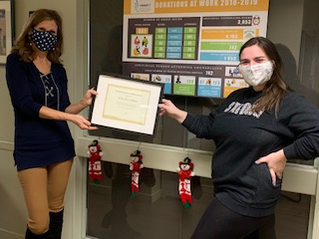

**YOU ARE COLLECTIVE SUPPORTING TRAUMA COUNSELLING IN OUR COMMUNITY!**

You Are Collective is a mental health social enterprise to empower and share lived experience to end the stigma surrounding Mental Health struggles.

# WHO WE ARE

#### ADMINISTRATIVE TEAM

Executive Director: Roxie Van Aller Office Manager: Joanna Shaw Administrative Support: Bonnie Williams Finance Coordinator: Lynda Fillion Gabrielle Smith-Lee (Volunteer)

**COUNSELLING STAFF**

Suzanne Harrington Joyce Eng

Michelle DeVies John Downes Kim Wardman

Angela Kazmierczak Roxie Van Aller

**COUNSELLING CONTRACTORS**

JB Cole Liz Sage

Jeff Goreski

Lisa Binnie

Michael Patzer

Alysha Punnett

Tamara Aspell

**BOARD**

Board Chair: Caitlyn Harris Co-Chair: Michelle Sinotte Secretary: Mark Smed Treasurer: Cinda Carlston Terry Smith

Stephen Somerville

Ann Haymond-Hill Nancy Guy