ANNUAL GENERAL REPORT 2022

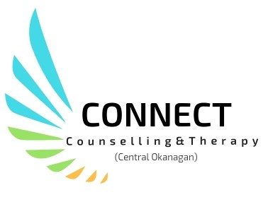

Counselling for the Community

Connect Counselling & Therapy: Central Okanagan

Tel: 250-860-3181 Fax: 250-860-3188

204-347 Leon Avenue

Email: reception@connectcounsellingsociety.ca

www.connectcounsellingsociety.ca
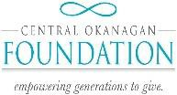
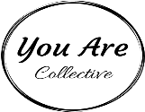

Message from the Executive Director and The Board of Directors

Every day we have the privilege of connecting with individuals, couples and families in an effort to improve mental health in our community. Virtual counselling has become mainstream, enabling us to make connections with individuals that otherwise might not have made connections with our services. COVID has helped to reduce the stigma of reaching out for support and shone a spotlight on mental health. This past year Connect provided 3334 counselling sessions to 679 individuals up from 541 last year.
We have all been impacted by this pandemic and the ongoing challenges continue to impact our lives. We all are working to deal with the new normal and uncertainty. What can be said with certainty is that Connect continues to work towards making mental health possible to all community members who reach out to us.
Highlights:

When long time counsellor Joyce Eng took well-deserved retirement from core programming, Connect faced a real challenge recruiting for a part time position in the Short-Term Counselling Program! Although it took some time, the program welcomed Bonnie Pontalti to the team in April. We’re thrilled to have Bonnie join our team. Our heartfelt thanks to Joyce for her years of service to Connect and our clients.
We have continued to build our social enterprise, offering our highly skilled services to individuals through ICBC, First Nations health authority and Autism BC. Our ongoing goal is always to provide more free counselling services to the community. This year the program provided counselling services to 355 individuals/families/couples up from 176 the previous year!
The Roots of Self-Discovery was once again offered with a grant through Civil Forfeiture. The group provides a safe place for men who have experience trauma to explore its impact and develop tools that promote a healthy relationship with self and others.
With support from Emergency Funding through the Central Okanagan Foundation we provided an online group for youth who were experiencing anxiety due to COVID-19. This funding supported 16 youth struggling to cope with the challenges of online learning and separation from peers and family.
The City of Kelowna provided funds for ongoing support to women who were at increased risk of intimate partner violence, by providing funds for a Domestic Violence Advocate and Navigator, with 65 women receiving support, helping to reduce women’s counselling waitlist time.

Somatic Experiencing Training continued online! Intermediate 1, 2 & 3 were completed. Faculty member Dea Parsanishi from the Somatic Experiencing Institute continued to inspire and challenge students attending the online training. We have expanded our trainings and will be providing 5 Somatic Experiencing courses next year.

It gives Roxie great pride to be the leader of this team! The team’s hard work and dedication continues to be inspiring. The success of the organization would not be possible without your contribution! The board is so grateful for the leadership Roxie has provided during this time of change and growth. None of our success would be possible without her.

We remain grateful for all of you who have supported us in whatever way you were able. We look forward to brighter days ahead!

Roxie Van Aller, Executive Director

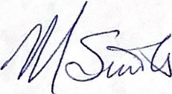
Michelle Sinotte, Board Chair

WHAT WE DO

Mission: To offer affordable, high quality, non-crisis care to improve the mental health of our diverse clients, their families and their communities.

Connect Counselling & Therapy currently focuses on 6 broad service areas, which include:

- Individual counselling for Women, Children/Youth & Men
- Groups for Women, Children & Men
- Couples Counselling
- Trauma Counselling
- Fee for Service
- Parenting Education

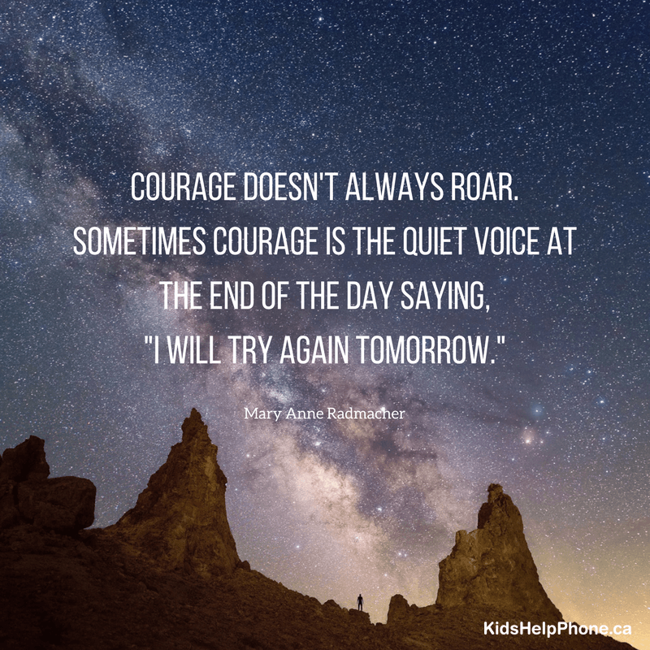

Impact:
Improved overall mental health and well-being of all residents of the Central Okanagan who seek support, leading to measurably stronger, healthier communities.

Counselling for Women, Children/Youth & Men
Women’s Counselling,
Individual and group counselling to women over the age of nineteen who have experienced childhood abuse, abuse in adult relationships and/or sexualized violence.

Short term Counselling for balancing the demands of family, struggles with life transitions or losses, relationship conflicts.

Children & Youth Counselling
Services for children, youth and their families who may be experiencing challenges with difficult behavior, separated or blended families, parent/child conflicts, parenting, grief, loss and sexual intrusive behavior.

Men’s Counselling
Provides individual (short term) and/or group counselling based on the needs of men who would like to improve their relationships, reduce stress and manage conflict.

“I was a participant in group and wanted to give you some feedback on the group. I found the group extremely helpful and informative, the facilitators were fantastic in their kind and compassionate approach. I was so happy to have in-person groups resume again, and I truly appreciate your efforts in making that happen. Every member found some benefit to the group, and all of us made some great strides towards a healthier mental state. Thank you again for providing an open, safe place for us to discuss our issues, and begin to move on from our pain”. Men’s Group Participant

Couples Counselling
Provides a safe place where couples can explore relationship difficulties and work to resolve interpersonal conflict, improve communication and increase intimacy.
Fee for Service
Fee for service is available for individuals who wish to pursue counselling issues not already covered by regularly funded programs.

Groups for Women, Children, Men and Families

SOOTHE for Children
- A course to support children aged 6-12 to reduce anxiety. A parenting component included.

Children & Change Group
- A group for children aged 6-12 whose parents have separated or divorced.

Parenting Skills Class
- Supports parents in developing skills to address challenging behaviours in their children or teens.
Reaching Older Women (ROW) Group
- For women 50+ who have experienced historical or current intimate partner violence.
Rebuilding For Adults
- A psycho-educational group for adults who would like information and support after their relationship ends.

Ongoing Drop-in Groups

Finding Our Voices Drop-in Group
- A group for women impacted by childhood and/or relationship abuse.

Men in Change
- A process group for men who are interested in learning how to manage emotions and conflict. Themes include: unfairness, boundary work, respectful communication, family conflict, solution-focused work, managing anger, emotional intelligence, shame
and resiliency.

Men in Relationship with Self and Others
- A group for men striving to improve their communication or relationship skills, conflict resolution skills, and who may be struggling with separation or divorce.
What Clients are Saying:
Amazing to get to talk about “it” and learn how to get through one problem”. Individual therapy client.
“Very helpful to rethink how reacting to him and the pain he’s going through and practicing one of not getting drawn in”. Couple’s Counselling Client

Parenting Education

Parenting Skills Class
- Supports parents in developing skills to address challenging behaviours in children or teens.

“When I first started this class, I thought you were going to tell me how to fix my kid. But then I realized that it wasn’t my kid that needed fixing. It was me! When I changed the way I parented my kid, my kid changed, I changed, and so did our relationship”. Parenting Group Participant

WHY IT MATTERS

“Where do I even begin to start to explain how much the Men’s Trauma Group has truly helped me to overcome a lot of obstacles. When I first started - I struggled with the idea of spending time with other men who hesitate to talk about their issues.

After a couple of meetings, I became pleasantly surprised to see that we all shared the same symptoms as related to our PTSD. I now realize if it hadn’t been for this group - I would have never even guessed how deeply one event can alter the quality of one’s life - after the fact. I wouldn’t have developed mechanisms to deal with this situation.

Through many sessions of mindful introspection led by wonderful sincere counsellors - through moments of watching others open up - I was able to open up and walk away from this experience with a great satisfaction of realizing that big changes can truly last when they happen in small increments.

These are humbling statements from a guy whose friends are a little befuddled as to how I ended up here? I’m happier now, easier-going, and even less fearful than a few months ago. I am actively involved with many other wonderful support mechanisms.

COMMUNITY NEED

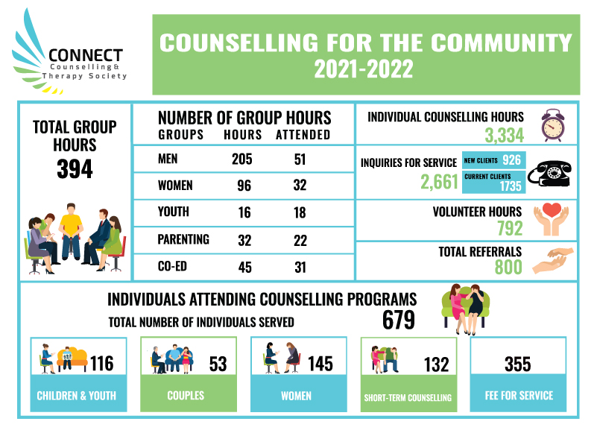

Connect Counselling & Therapy

Usage | Year: 2021-22 | Year: 2020-21
Inquiries for service | 2661 (926 New & 1735 current) | 1190
Referrals | 800 | 778
Counselling hours | 3,334 | 3,114
Group hours | 397 | 485
Fee for Service | 355 | 176
Volunteer Hours | 792 | 730
Total Clients Served | 679 | 541

FINANCIAL STATEMENT

Connect Counselling and Therapy Society (Kelowna Family Centre)

Statement of Financial Position March 31, 2022
(Unaudited)

2022 2021

Assets
CURRENT
Cash $ 272,093 $ 193,966
Accounts receivable 5,508 7,752
Prepaid expenses 8,528 3,067

286,129 204,785

Property, Plant & Equipment (Note 5) | 10,252 | 7,542
RESTRICTED CASH (Note 4) 25,183 25,043
LIABILITIES AND NET ASSETS | $ 321,573 | $ 237,370
CURRENT  Accounts payable | $ 7,471 | $15,848
Goods & services tax payable | 1,768 | 1,187
Wages payable | 29,968 | 34,531
Employee deductions payable | 155
Deferred revenue (Note 6) 79,990 51,533

119,352 110,788

NET ASSETS
Unrestricted net assets | 166,777 | 93,997
Restricted net assets (note 4) | 25,192 | 25,043
Net assets invested in capital (note 5) | 10,252 | 7,542
 | 202,221 | 126,582
 | $321,573 | $237,370
STATEMENT OF REVENUES & EXPENDITURES

Connect Counselling & Therapy Society (Kelowna Family Centre)

Year Ended March 31, 2021 (Unaudited)

2022 2021

REVENUES  Counselling | $ 98,106 | $ 49,866
Donations and Fundraising | 15,319 | 15,147
Grant - Community Gaming (Note 3) | 14,703 | 28,524
Grants - Other | 102,003 | 125,093
Grants - Provincial Government | 442,923 | 428,585
Somatic Experience course fundraiser (Note 7) | 106,211 |  | 88,720
Intake Fees | 10,536 |  | 1,725
Interest | 499 | 411
 | 790,300 | 738,071
COST OF SALES
Contract services | 54,563 | 43,649
Program supplies | 2,490 | 2,390
Salaries and benefits | 438,258 | 426,617
Travel | 792 | 487
 | 496,103 | 473,143
GROSS PROFIT | 294,197 | 279,473
EXPENSES  Advertising | 2013 | 2,146
Amortization | 2,682 | 1,865
Communication | 5,647 | 4,893
Fundraiser expenses | 4,107 | 1,079
General and board meetings | 1,653 | 1,650
Insurance | 4,932 | 4,670
Office and general | 24,508 | 27,736
Professional development | 6,429 | 7,349
Professional fees | 5,349 | 5,176
Purppl community enterprise | 9,601 | 19,165
Rent | 38,842 | 38,842
Repairs and maintenance | 3,831 | 3,600
Salaries and wages | 32,604 | 25,052
Somatic Experience course expenses (Note 7) | 74,750 | 60,218
Security | 560 | 954
 | 217,508 | 204,395
EXCESS OF REVENUES OVER EXPENDITURES OPERATIONS | 76,689 | 60,533
Loss on disposal, plant and equipment _ (1050)_________ (1,786)_

EXCESS OF REVENUES OVER EXPENDITURES $ 75,639 $ 58,747

HOW YOU HELP

VOLUNTEERS
Our volunteers help in many ways, from becoming a board member, administrative support, fund development and fundraising.

DONATIONS
We rely on the generosity of the community and grants in order to provide the programming and do what we do. The support we receive from fund-raising events, donations and third-party events makes all the difference!

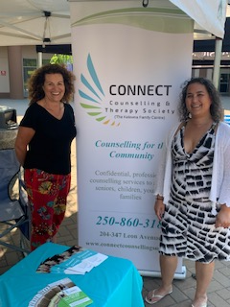

Dream Rally

WHO WE ARE

ADMINISTRATIVE TEAM
Executive Director: Roxie Van Aller Office Manager: Joanna Shaw Administrative Support: Bonnie Williams Finance Coordinator: Lynda Fillion Gabrielle Smith-Lee (Volunteer)

COUNSELLING STAFF
Suzanne Harrington
Michelle DeVies John Downes Kim Wardman
Angela Kazmierczak Roxie Van Aller

COUNSELLING CONTRACTORS
JB Cole
Jeff Goreski
Lisa Binnie
Michael Patzer
Joyce Eng
Tamara Aspell
Darcy Kuhl
Shirin Abtahie
Alysha Punnett

BOARD
Chair: Michelle Sinotte
Co-Chair: Caitlyn Harris
Secretary: Mark Smed Treasurer: Cinda Carlston Terry Smith
Ann Haymond Hill Nancy Guy
Lakatie Naka

